Soil Organic Carbon Stocks in Different Land Uses at Puthupet, Tamil Nadu, India

SM Sundarapandian*, S Amritha, L Gowsalya, P Kayathri, M Thamizharasi,
Javid Ahmad Dar, K Srinivas, D Sanjay Gandhi, K Subashree
Department of Ecology and Environmental Sciences, Pondicherry University, Pondicherry, India

Abstract
Soil organic carbon (SOC) stocks were assessed in different land uses i.e., Cocos nucifera, Anacardium occidentale, Mangifera indica, Casuarina equisetifolia plantations, wasteland and natural forest at Puthupet, Tamil Nadu, India using Walkley and Black’s method. The soil bulk density was found to increase significantly (P< 0.05) with the increase in soil depth in all the sites except natural forest. Highest bulk density was recorded in wasteland and the least was from the forest, which could be due to the compaction of soil. In natural forest, soil is loose due to fine root mats, microbial and other arthropod activities which help in the aeration resulting in low bulk density. The highest percentage of SOC was recorded in the natural forest. This may be because natural forests are undisturbed ecosystems with large litter inputs, high microbial activities and decomposition leading to accumulation of more humus in soil, whereas other land uses receive low litter inputs. The casuarina plantation is a young one and litter in coconut plantation is utilized by stakeholders, which reasons for low detritus input. Soil organic carbon and soil organic matter (SOM) showed a positive correlation with tree density and tree basal area, while they showed a negative correlation with soil bulk density. The present study reveals that the maintenance of tree population for long-term would increase the SOC concentration.

Keywords: Soil organic carbon, bulk density, decomposition, litter fall, soil moisture

*Author for Correspondence E-mail: smspandian65@gmail.com

INTRODUCTION
The tropical dry forests in the world are under strong and continuous pressure, due to high rates of deforestation and degradation by anthropogenic perturbations, overgrazing, conversion of monoculture plantations and other developmental activities [1]. The landuse change in the tropics has resulted in CO₂ emissions of about 1.6 Pg C yr⁻¹ in the 1990s [2]. Land use management is considered to affect the amount of soil organic carbon (SOC) and land use changes can result both in losses and gains of SOC [3].

To estimate the ‘C’ credits of afforestation or reforestation in clean development mechanism (A/RCDM) (the net increase in ‘C’ stocks caused by project activities), it is necessary to know the ‘C’ fixation baseline, by assuming the perpetuation of various landscapes. However, soil organic carbon stocks change in various land-use systems and the paucity of baseline data has always interfered with the application and promotion of A/R CDM projects [4]. Land-use changes strongly affect soil C storage [5, 6]. SOC is a large reservoir that can act as a sink or a source for atmospheric CO₂ [7]. Therefore, a relatively small change in the soil ‘C’ pool can precipitate a large effect on the ‘global C cycle’.

However, the effects of human activity on soil C dynamics are not fully understood [8]. Various studies have been conducted to study the effects of land-use change on soil ‘C’ dynamics in tropical regions after land conversion from the forest to a cultivated land [9–11] or a pasture [12–14]. SOC change associated with this type of land use change is a major concern.

The amount and rate of SOC change were highly dependent on the specific land transition [15]. Decreases in SOC stocks are usually most pronounced in the topsoil, although older plantations have considerable SOC losses below 1m depth [16].
However, information on comparison of SOC stocks in various land-uses with natural dry tropical forests has been very limited, especially in the Coromandel coasts of India. In fact, the Coromandel coast has unique climatic conditions which support large number of small patches of tropical dry evergreen forests. Although biomass and carbon stocks of woody vegetation of the study area were assessed [17], SOC stocks were not estimated so far. Therefore, the present study was designed with the following objectives: firstly to examine the variation in SOC stocks in different land use systems and secondly to examine the relationship of SOC stock with various edaphic factors.

MATERIALS AND METHODS
Study Area
The study was conducted in different land use systems by means of four plantations (Cocos nucifera, Anacardium ocidentale, Mangifera indica and Casuarina equisetifolia), wasteland and a natural forest at Puthupet, located 15 km north of Pondicherry town (Table 1). The mean annual temperature was 28.5 °C and the mean annual rainfall was 1311 mm. The number of mean annual rainy days is 55.5. The mean monthly temperature was 24.1–34.2 °C. The climate is tropical dissymmetric with copious rainfall during the northeast monsoon from October to November. Summer prevails from March to May during which there are occasional showers due to southwest monsoon until September [18].

Table 1: Density and Basal Area of Tree Species in Different Land Uses in Puthupet,
Tamil Nadu, India.
Name of species | Location | No. of individuals/ha | BA (m²/ha)
Anacardium occidentale | N=12° 05’ 627”  E= 79° 85’ 899” | 244 | 5.8
Casuarina equisetifolia | N=12° 05’ 564”  E= 79° 86’ 794” | 3200 | 6.7
Cocos nucifera | N=12° 05’ 862”  E= 79° 86’ 32” | 232 | 15.8
Mangifera indica | N=12° 05’ 376”  E= 79° 86’ 967” | 204 | 14.5
Natural forest | N=12° 05’ 702”  E= 79° 87’ 148” | 660 | 28.1

Soil sampling and laboratory analysis
Soil samples were collected at 0–10, 10–20 and 20–30 cm depth from each site using a core sampler in the months of January and February of the year 2013. Ten sets of samples were collected from each study site and are mixed together to form a composite soil sample, from which six replicate samples were brought to the laboratory for further analysis. Before analysis, soil samples were sieved through a 2 mm mesh and then mixed thoroughly. Walkley and Black’s method [19] was used to estimate SOC. In this method, as only about 60–86% of SOC is oxidized, a standard correction factor of 1.32 was used to obtain the corrected SOC values [20].

For bulk density in each site, six aggregated undisturbed soil cores were taken using a soil corer with an internal diameter of 5 cm. The soil samples were weighed immediately and transported to the laboratory where they were oven-dried at 105 °C for 72 h and re-weighed again. In the soils containing coarse rocky fragments, the coarse fragments were separated by sieve and weighed. The bulk density of the mineral soil core was calculated with the help of the formula [21]. SOC stocks were then calculated for each soil layer based on the thickness, bulk density and carbon concentration. The total carbon content upto 30 cm depth was finally estimated by summing the C concentration of all layers [21].

Statistical Analysis
The variation in SOC stocks among the different landuses and soil depths (0–10, 10–20, 20–30 cm) was examined with analysis of variance (ANOVAs). The relationship between SOC stock and 5 variables (soil moisture, soil pH, bulk density, tree density and tree basal area) were assessed with correlation analysis followed by linear regression.

RESULTS
The soil moisture (SM) percent in different landuses of Puthupet ranged from 2.45 (Casuarina plantation) to 8.93 (coconut plantation) up to 30 cm soil depth (Figure1). The soil moisture percent significantly (P< 0.001) varied among the study sites. Coconut plantation showed significantly (P< 0.05) higher soil moisture (8.93%) than the other study sites. On the other hand, the soil pH across these different landuses ranged from 5.33 (cashew nut plantation) to 7.3 (coconut plantation) upto 30 cm soil depth (Figure1). The pH was also significantly (P< 0.001) greater in coconut plantation when compared with natural forest, cashew nut, Casuarina and mango plantations.

Fig. 1: Soil Moisture and pH in Different Land Uses in Puthupet, Tamil Nadu, India.

The soil bulk density (BD) in these different landuses ranged from 1.19 (forest) to 1.64 (wasteland) upto a depth of 30 cm (Figure 2). The soil bulk density was found to increase significantly (P< 0.05) with increase in soil depth in all the sites except natural forest. Wasteland and mango plantation also showed significantly (P< 0.05) greater bulk density than the other study sites. The mean range of bulk density in different depths was 1.19 (cashew nut plantation) to 1.47 (wasteland) at 0–10cm, 1.12 (forest) to 1.82 (wasteland) at 10–20 cm and 1.21 (forest) to 1.63 (wasteland) at 20–30cm. Significant differences (P< 0.05) were found to exist along the soil profile in all the sites except Casuarina plantation.

Fig. 2: Soil Bulk Density in Different Land Uses in Puthupet, Tamil Nadu, India.

SOC percent in different landuses (plantations, natural forest and wasteland) ranged from 1.05 (wasteland) to 2.12 (forest) up to 30 cm soil depth (Figure 3). SOC stock percent significantly (P< 0.001) decreased with increase in soil depth in all the sites except cashewnut plantation. Natural forest had significantly (P< 0.05) greater SOC percent than the other sites, which is followed by Casuarina plantation.

The mean range of SOC percent in different depths was 0.377 (wasteland) to 0.915 (forest) at 0-10cm, 0.172 (mango plantation) to 0.66 (natural forest) at 10–20 cm and 0.25 (mango plantation) to 0.55 (forest) at 20–30cm.

The soil organic matter SOM (%) in the present study ranged from 3.25 (mango plantation) to 7.12 (forest) in 0–30 cm soil depth (Figure 3). The stock of SOM (%) significantly (P< 0.001) decreased with increase in soil depth in all the sites except cashew nut plantation. Forest had the significantly (P< 0.05) greatest SOM % than the other sites.

However, the least SOM% was observed in mango plantation. The mean range of SOM % in different depths was 1.12 (wasteland) to 3.52 (forest) at 0–10 cm, 0.51(mango plantation) to 1.95 (forest) at 10–20 cm and 0.74 (mango plantation) to 1.63 forest) at
20–30cm.

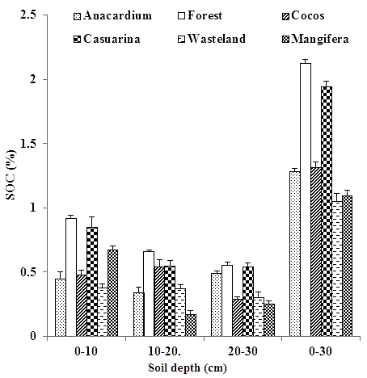 | 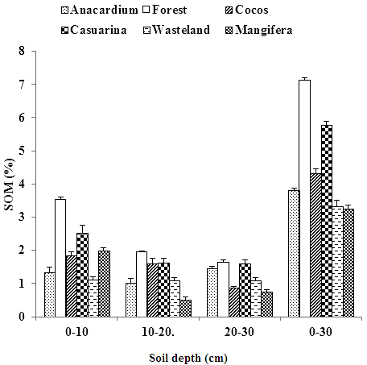
Fig. 3: Soil Organic Carbon (SOC) and Soil Organic Matter (SOM) in Different Land Uses in Puthupet, Tamil Nadu, India.

The total SOC stock (Mg C ha⁻¹) up to 30 cm soil depth in the study sites ranged from 15.66 (cashew nut plantation) to 29.02 (forest; Figure 4). The mean range of total soil carbon (Mg C ha⁻¹) in different depths was 5.35 (cashew nut plantation) to 14.94 (forest) at 0–10 cm, 2.70 (mango plantation) to 7.56 (Casuarina plantation) at 10–20 cm and 3.71 (mango plantation) to 6.88 (Casuarina plantation) at 20–30 cm. The total carbon stock was significantly (P< 0.001) greatest in forest than the other study sites.

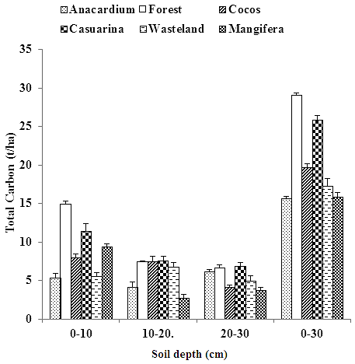
Fig. 4: Total Soil Organic Carbon (t/ha) in Different Land Uses in Puthupet, Tamil Nadu, India.

Regression analysis revealed that tree density and basal area showed positive relationship with SOC percent, SOM and total carbon (Mg C ha⁻¹) in different land uses of Puthupet (Figure 5). However, bulk density showed only a negative relationship with SOC percent, SOM and total carbon (Mg C ha⁻¹).

Fig. 5: Regression of Soil Organic Carbon (SOC), Soil Organic Matter (SOM) and Total Carbon (TC) with Tree Density, Basal Area and Bulk Density in Different Land Uses in Puthupet,
Tamil Nadu, India.

DISCUSSION
The highest percentage of SOC was recorded in natural forest than all other landuses. This may be due to the fact that natural forests are undisturbed ecosystems with large litter inputs, high microbial activities and decomposition leading to the accumulation of more humus in soil, whereas in contrast, plantations receive low litter inputs. The casuarina plantation is a young plantation and litter in the coconut plantation is utilized by stakeholders, which reasons for low detritus input.

However, the wasteland had the lowest SOC stock due to lack of vegetation cover and its associated microclimate. Our results are in agreement with the findings of other workers [22–25]. However, our results are lower than the results reported in other works [26, 27]. Our results also indicate that vegetation type has significant effects on the quantity of SOC as it is low in plantations and high in natural forest. Our results are also consistent with other reports [28, 29]. Vegetation types can alter SOC stocks through several key factors, including litter inputs through litterfall and root turnover [23], soil chemistry [30], root exudates and microclimate.

Soil bulk density showed a positive relationship with increase in soil depth. The highest value of bulk density was recorded in wasteland, while the least was observed in forest. High bulk density in wasteland may be due to compaction of soil which is contrary to the natural forest where the soil is made loose due to fine root mats, microbial and arthropod activities, leading to aeration of the soil. There is a positive correlation of bulk density with soil depth [25]. SOC showed positive correlations with tree density and tree basal area, but a negative relationship with soil bulk density. SOM and the total SOC stocks also showed the same trend. A negative correlation of SOC with bulk density was also reported by others [24, 25]. A positive correlation of tree density with SOC was observed in the subtropical forests of China [28]. The greater tree density results in greater litter accumulation in the forest floor which enhances greater buildup of carbon in the soil.

CONCLUSION
The present study reveals that maintenance of tree populations for a long-term will increase SOC concentration in soils. Litter falling in different landuse systems ought to be allowed to decompose in the site itself as this would enhance carbon sequestration. Instead of mono-cropping systems, mixed cropping would be best suitable as the latter would enhance more carbon storage in soils.

REFRENCES
- Chaturvedi et al. Leaf attributes and tree growth in a tropical dry forest. J. Veg. Sci. 2011.doi:10.1111/ j.16541103.2011.01299.
- Denman KL, Brasseur G, Chidthaisong A et al. Couplings Between Changes in the Climate System and Biogeochemistry. In:Solomon S, Qin D, Manning M, et al., editors. Climate Change 2007: The Physical Science Basis. Contribution of Working Group I to the Fourth Assessment Report of the Inter-governmental Panel on Climate Change. Cambridge University Press, Cambridge, United Kingdom and New York, NY, USA; 2007.
- Wiesmeier M, Lutzow V, Sporlein P et al. Land use effects on organic carbon storage in soils of Bavaria: The importance of soil types. Soil Tillage Res. 2015; 146: 296–302p.
- IPCC. Guidelines for national greenhouse gas inventories. Kanagawa, Japan, National Greenhouse Gas Inventories Programme; 2006.
- Guo LB, Gifford RM. Soil carbon stock and land use change: a meta-analysis. Glob. Change Biol. 2002; 8: 345–60p.
- Post WM, Kwon KC. Soil carbon sequestration and land-use: processes and potential. Glob. Change Biol.2000; 6: 317–27p.
- Lugo AE, Brown S. Management of tropical soils as sinks or sources of atmospheric carbon. Plant Soil. 1993; 149: 27–41p.
- Murty D, Kirschbaum MUF, McMurtrie RE et al. Does Conservation of forest to agricultural land change soil carbon and nitrogen. A review of the literature. Glob. Change Biol. 2002; 8: 105–23p.
- Andreux F, Cerri C, Vose PB et al. Potential of stable isotope, ¹⁵N and ¹³C, methods for determining input and turnover in soils. In: Harrison AF, Ineson P, Heal OW, editors. Nutrient cycling in terrestrial ecosystems. Elsevier, London; 1990; 259–75p.
- Islam KR, Ahmed MR, Bhuiyan MK et al. Deforestation effects on vegetative regeneration and soil quality in tropical semi-evergreen degraded and protected forests of Bangladesh. Land Degrad. Dev.2001; 12: 45–56p.
- Vitorello VA, Cerri CC, Andreux F, et al. Organic matter and natural carbon ¹³Cdistribution in forested and cultivated Oxisols. Soil Sci. Soc. Am. J.1989; 53: 773–8p.
- Desjardins T, Barros E, Sarrazin M, et al. Effects of forest conversion to pasture on soil carbon content and dynamics in Brazilian Amazonia. Agric. Ecosyst. Environ. 2004; 103: 365–73p.
- Neill C, Cerri CC, Melillo JM, et al. Stocks and dynamics of soil carbon following deforestation for pasture in Rondônia.In: Lal R, Kimble JM, Follett RF et al. editors.Soil processes and the carbon cycle. CRC, New York; 1997. 9–28p.
- Veldkamp E. Organic carbon turnover in three tropical soil sunder pasture after deforestation. Soil Sci. Soc. Am. J. 1994; 58: 175–80p.
- Qin Z, Dunn JB, Kwon H, et al.Soil carbon sequestration and land use change associatedwith biofuel production: empirical evidence. Glob. Change Biol. 2015; doi: 10.1111/gcbb.12237.
- Wolf et al. Conversion of lowland tropical forests to tree cash crop plantations loses up to one-half of stored soil organic carbon. PNAS. 2015; 112(32): 9956–60p.
- Sundarapandian SM, Amritha S, Gowsalya L et al. Estimation of Biomass and Carbon Stock of Woody Plants in Different Land-Uses. For. Res. 2013; 3(1): 115p.
- Parthasarathy N, Sethi P. Trees and liana species diversity and population structure in a tropical dry evergreen forest in south India. Trop. Ecol.1997. 38: 19–30p.
- Walkley A. An estimation of methods for determining organic Carbon and Nitrogen in soil. J.Agr. Sci.1947; 25: 598–609p.
- De Vos B, Letten S, Muys B et al. Walkley-Black analysis of forest soil organic carbon: recovery, limitations and uncertainty. Soil Use Manage.2007; 23: 221–9p.
- Pearson T, Walker S, Brown S. Source Book for LULUCF Projects. Winrock International, Arlington, VA, USA; 2005.
- Djomo AN, KnohlA, Gravenhorst G. Estimations of total ecosystem carbon pools distribution and carbon biomass current annual increment of a moist tropical forest. For. Ecol. Manage. 2011; 261: 1448–59p.
- Jandl R, Vesterdal L, Olsson M et al. Carbon sequestration and forest management.CAB Reviews: Perspectives in Agriculture, Veterinary Science, Nutrition and Natural Resources. 2007; 2(17): doi: 10.1079/PAVSNNR20072017.
- Li P, Wang Q, Endo T, et al. Soil organic carbon stock is closely related to aboveground vegetation properties in cold-temperate mountainous forests. Geoderma2010; 154: 407-15p.
- Jobbagy EG, Jackson RB. The vertical distribution of soil organic carbon and its relation to climate and vegetation. Ecol. Appl. 2000; 10: 423–36p.
- Sundarapandian SM, Dar JA, Gandhi DS, et al. Estimation of biomass and carbon stocks in tropical dry forests in Sivagangai District, Tamil Nadu, India. Int. J. Env. Sci. Eng. Res. 2013; 4(3): 66–76p.
- Frazao LA, Paustian K, Cerri CEP, et al. Soil carbon stocks under oil palm plantations in Bahia State, Brazil. Biomass Bioenerg.2014; 62: 1–7p.
- Wang H, Liu SR, Mo JM, et al. Soil organic carbon stock and chemical composition in four plantations of indigenous tree species in subtropical China. Ecol. Res.2010; 25: 1071–9p.
- Russell AE, Raich JW, Valverde OJ et al. Tree species effects on soil properties in experimental plantations in tropical moist forest. Soil Sci. Soc. Am. J. 2007; 71(4): 1389–97p.

- Mulder J, De Wit HA, Boonen HWJ et al. Increased levels of aluminum in forest soils: effects on the stores of soil organic carbon. Water Air Soil Pollut. 2001; 130: 989–94p.
Cite this Article
SM. Sundarapandian, S. Amritha, L. Gowsalya et al. Soil organic carbon stocks in different land uses at Puthupet, Tamilnadu, India. Research & Reviews: Journal of Ecology. 2015; 4(3): 6–14p.

