Vegetable Oil as An Eco-Friendly Cutting Fluid for Different Machining Operation: Review

TN Khilosia, AL Dudhatra, BJ Saradava
Department of Mechanical Engineering, Atmiya Institute of Technology and Science,
Rajkot, Gujarat, India

Abstract
Fluids used in machining are used to enhance the production rates and metal cutting quality. Their use causes a threat to environment and also to the worker’s health. So, there is a need to find environmental friendly substitute to conventional mineral oil for fluid used in metal working. Vegetable oil can be used as a metal working fluid because it has certain advantages like good lubrication performance, renewability and biodegradability. This paper gives the review of performance of different vegetable oils used for machining process of various materials.

Keywords: Vegetable oil, cutting fluid, machining operations

*Author for Correspondence E-mail: tnkhilosia@aits.edu.in

INTRODUCTION
For minimizing, the friction and wear between the two surface lubricants are generally used. It can also be used to remove heat, transmit power, to prevent corrosion and to remove wear particles. For the most of machining operations, metal working fluids are generally used. In 1907, Taylor first identified the use of coolants for machining operations and the cutting speed was increased up-to 40% during machining of steel by using high speed steel tool and the coolant used was water.

Generally, friction is produced in metal working operations when material is removed in the form of continuous or discontinuous chip at the rake face of cutting tool. To reduce the friction, lubrication is used which enters between contact surface of tool and chip. So, due to lubrication there is reduction in vibration and cutting force which results into smooth machining operation and the quality of machining is also improved. Also due to lubrication, the tool life can be increased and also the surface finish can be improved.

Vegetable oils are obtained from plants and then it can be refined to obtain certain necessary properties. As compared to the mineral oil based fluid, vegetable oil based cutting fluid gives better lubrication and also their viscosity decreases significantly when reaches to the high temperature. Also the overall amount of fluid which is used for lubrication can be reduced by using vegetable oil cutting fluid.

The vegetable oil fluid cutting will not affect the worker’s health as it is eco-friendly. Due to these advantages of vegetable oil cutting fluid it has now been considered as a good substitution of mineral oil based cutting fluid.

LITERATURE REVIEW
Kolawole and Odusote studied the performance of different vegetable oils like palm oil, groundnut oil etc., and the results were compared with that of mineral oil-based cutting fluid during the machining operation of mild steel [1]. Chip formation rate and temperature of work piece were measured using different parameters like feed, speed and depth of cut.

The cutting fluids used were vegetable oil like groundnut and palm oil. The results obtained were compared by using mineral oil based fluid for machining band during dry machining.

The graph below shows the temperature of work piece with a feed rate of 0.25 mm/rev and depth of cut 15 mm using different cutting speed and cutting fluids (Figure 1).

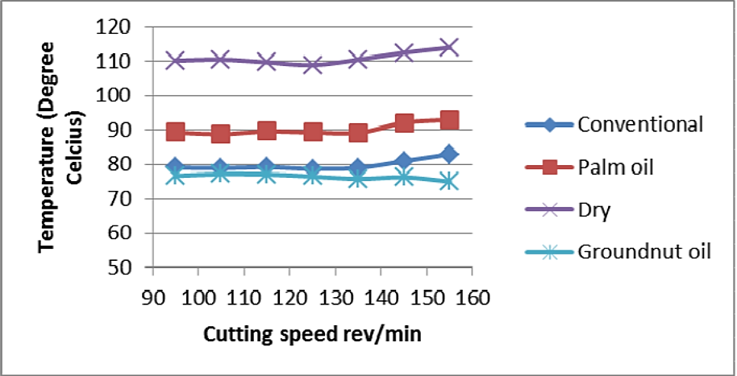
Fig. 1: Temperature of Work Piece (vs.) Feed Rate Using Different Cutting Speed and Cutting Fluids.

The second graph shows the temperature of work piece by using different vegetable oils as cutting fluids at various depth of cut. The cutting speed taken was 95 rev/min and feed rate was 0.25 mm/rev (Figure 2). On the basis of the result obtained it was concluded that palm and groundnut oils can be used as a lubricant over mineral oil for mild steel machining.

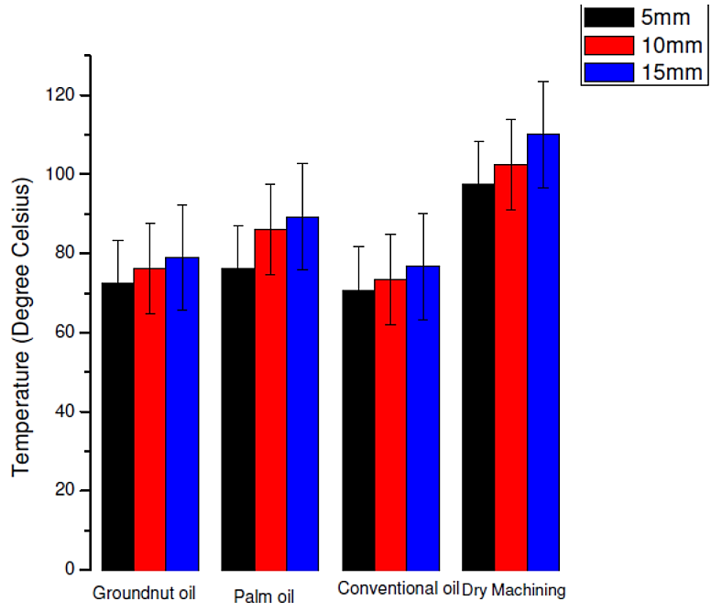
Fig. 2: Temperature of Work Piece by Using Different Vegetable Oils at Various Depth of Cut.

Saleem carried out turning operations on a centre lathe machine by using mustard oil as a coolant [2]. The H.S.S single point cutting tool was used for the turning operation. The turning operation was carried out at a constant speed of 250 rpm with feed rate of 0.06 mm/rev and depth of cut was 0.2 mm. The tool nose radius was 0.8 mm. The results obtained were compared with conventional coolant on the basis of tool life and tool wear. The result of tool temperature for dry cutting, conventional coolant and for mustard oil are shown in the below Table 1.

Table 1: Result of Tool Temperature for Turning Operations.
Tool Temperature After Machining °C
Dry Cutting | Conventional Coolant |  | Mustard Oil As Coolant MLQ Technique
 | 10% MoS2 + SAE-40 Base oil | 10% Boric acid + SAE-40
Near About 300 | 200–230 | 180–200 | 200–250

From the above Table 1, it can be concluded that for turning operation vegetable oil can be used as effective cutting oil. And it was observed that mustard oil can be used at high and low feed rates.

Alves and Oliveira used water and vegetable oil as coolant for grinding in CBN grinding process. The conventional surface grinder was used [3]. The test was performed by using CBN wheel on SAE 8640. The natural oil was sulfonate castor oil 80% and emulsifier was synthetic ester polyglycol. Radial wheel wear and roughness of work piece are the parameters used for measuring performance of coolant. It was observed that the lowest wear of wheel was obtained by using cutting oil and highest wear of wheel was obtained using semi-synthetic cutting fluid oil.

Krishna et al. measured nanoboric acid performance by doing turning operation with tool of cemented carbide and the material used was AISI 1040 steel [4–6]. The operation was carried using lathe machine. Effects of solid lubricant with respect to proportions of oil were studied on cutting temperatures, with cutting conditions. It was observed that wear of tool flank and roughness of surface and cutting temperature reduced by using nano-lubricants which is suspended in coconut oil.

OBJECTIVE OF PRESENT INVESTIGATION
The intention of the present work is to investigate scope and performance of vegetable oil based cutting fluid as an alternative to conventional cutting fluid.
CONCLUSION AND FUTURE WORK
From difference research paper it can be concluded that vegetable oil has got good scope to replace the conventional mineral oil for metal working operation. The performance of different vegetable oil gave promising sign for their future use.

REFERENCES
- Kolawole and Odusote. Performance Evaluation of Vegetable Oil-Based Cutting Fluids in Mild Steel Machining. Chemistry and Materials Research. 2013; 3: 9p.
- Saleem S Md., Khan Z Md., Zaka Z Md. et al. Vegetable oil as an alternative cutting fluid while performing turning operation on lathe machine using single point cutting tool. International Journal of Technical Research and Applications. Nov-Dec 2013; 1(5): 103–105p.
- Alves SM and JFG de Oliveira. Development of new cutting fluid for grinding process adjusting mechanical performance and environmental impact. Journal of Materials Processing Technology. 2006; 179: 185–189p.
- Krishna PV, Srikant RR, Rao DN et al. Experimental investigations on the performance of nanoboric acid suspensions in SAE-40 and coconut oil during turning of AISI 1040 steel. International Journal of Machine Tools & Manufactures. 2010; 50: 911–916p.

- Lawal SA, Choudary IA, Nukman Y et al. Application of vegetable oil-based metal working fluids in machining ferrous metals - A review. International Journal of Machine Tools & Manufacture. 2012; 52: 1–12p.
- Boyde S. Green Lubricants: Environmental benefits and impacts of lubrication, Uniqema lubricants, Wilton, UK. Green Chemistry. 2002; 4: 293–307p.
Cite this Article
TN Khilosia, AL Dudhatra, BJ Saradava.Vegetable oil as an eco-friendly cutting fluid for different machining operations: review. Research & Reviews: Journal of Ecology. 2015; 4(3): 15–18p.

