Reviewer Details
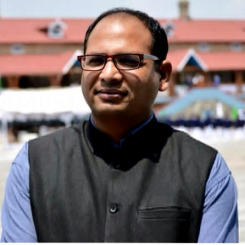
Name of Faculty member | Designation | Specialization: | Email id/ Phone | Department | University
Mr. P.C. Chanyal | Assistant Professor | Horticultural Practices & Agricultural Development, Regional Development & Planning | Prakash_chanyal78@yahoo.com  +91-9690659365 | Department of Geography | Kumaun University, Nainital, DSB Campus, Nainital


Name of Faculty member | Designation | Specialization: | Email id/ Phone | Department | University
Lala Iswari Prasad Ray | Assistant Professor | Irrigation and Drainage; Soil and Water Conservation; Water Resource Management; Dry land agriculture; Microirrigation | lalaiswariprasadray@yahoo.co.in. | School of Natural Resource Management, College of Postgraduate Studies, Umiam-793103,  Meghalaya, India | Central Agricultural University, Imphal, Barapani, Meghalaya-793103

