Phase Transition and Molecular Orientational Studies on Nematic Dimmer and Cholesteric Materials

T. N. Govindaiah

Research Centre, Post-Graduate Department of Physics, Government College (Autonomous),
Mandya-571401, India.

Address of the corresponding author:
Dr. T.N. Govindaiah
Asst. Professor,
Research Centre, P.G. Department of Physics,
Government College (Autonomous), Mandya-571401, India.
tngovi.phy@gmail.com

Short running title: Phase Transition and Molecular Orientational Studies on Nematic Dimmer and Cholesteric Materials

Keywords: Optical texture; Birefringence; layer spacing; Molecular orientation:

Phase Transition and Molecular Orientational Studies on Nematic Dimmer and Cholesteric Materials
ABSTRACT
The binary mixture of nematic dimmer and cholesteric compounds viz., cholesteryl nonanoate (CN) and 1,7-bis-4-(4′-cyanobiphenyl) heptane (CB7CB) exhibits very interesting liquid crystalline phase’s at large range of concentrations and temperature. The concentrations with lower/higher percentage of CB7CB exhibit cholesteric and reentrant smectic-A phases sequentially when the specimen is cooled from its isotropic phase. The molecular tilt and birefringence have been discussed in the region of smetic-A and smectic-C phases respectively at different temperature. The temperature variations of optical anisotropy have also been discussed.
Keywords: Optical texture; Birefringence; layer spacing; Molecular orientation:
INTRODUCTION
A new type of nematic liquid crystal, the twist-bend nematic was recently discovered. It has potential of leading to the next generation of electro-optical applications. And they characterized by long-range orientational order of the molecules are in symmetry position along the director: that they are expected to be about one hundred times faster than current devices. The structure of this phase is heliconical, in which the optic axis surprisingly adopts a helical trajectory even though the constituent molecules are achiral. The twist-bend phase is only the fifth nematic phase to be discovered and presents very interesting and unexpected scientific phenomena for researchers. Many of the researchers found to examine; the comparison of conventional mesophase properties of different compounds; in which the thermal stabilities of the nematic and twist-bend nematic phases of dimmer liquid crystals are significantly higher than those of conventional liquid crystalline materials: which are very closely related in chemical structure [1-3].
In the present investigation, our aim is to study the binary mixtures of nematic dimmer and cholesteric compounds, namely, cholesteryl nonanoate (CN) and 1,7-bis-4-(4′-cyanobiphenyl) heptane (CB7CB). Different concentrations of these molecules exhibits an cholesteric and induced chiral smectic phases such as SmA, SmC* SmC, reentrant SmA, and SmB respectively at different temperatures. These phases have been characterized by using optical anisotropic techniques for different concentrations and at different temperatures. Temperature variation of optical anisotropy and intermolecular interactions of the given binary molecules of CN in (CB7CB) have also been discussed.
EXPERIMENTAL STUDIES
In the present study, we use the materials, namely, cholesteryl nonanoate (CN) and 1,7-bis-4-(4′-cyanobiphenyl) heptane (CB7CB). Mixtures of different concentrations of CN in (CB7CB) were prepared and they were mixed thoroughly. These mixtures of concentrations were kept in desiccators for 6 hours. The samples were subjected to several cycles of heating, stirring and centrifuging to ensure homogeneity. Phase transition temperatures of these mixtures were measured with the help of a polarizing microscope in conjunction with a hot stage. The samples were sandwiched between the slide and cover slip, and were sealed for microscopic observations. The permitted temperature control was ± 0.1ºC. The level of liquid crystal in the capillary was read to ± 0.01mm with a cathetometer. The absolute error in the density measurements was Δρ = ± 0.0001 g/cc. The refractive indices in the optical region are determined at different temperatures by employing the techniques described by the earlier investigators [4, 5].
RESULTS AND DISCUSSIONS

OPTICAL TEXTURE STUDIES
The molecular orientations of optical textures exhibited by the samples were observed and recorded using the leitz-polarizing microscope in conjunction hot stage. The specimen was taken in the form of thin film and sandwiched between the slide and cover glass. The mixture of different concentrations of given molecules were slowly cooled from its isotropic melt. The genesis of nucleation starts in the form of small bubbles and slowly grows radially, which forms a spherulitic texture of cholesteric phase with large values of pitch [6, 7]. On further cooling the specimen, the cholesteric phase slowly changes over to focal conic fan shaped texture, which is the characteristics of SmA phase and is shown in Figure 1(a). The SmA phase is unstable and then it changes over to the SmC* phase, which exhibits radial fringes on the fans of focal conic textures, which is characteristic of the chiral SmC* phase. On further cooling the specimen, this phase slowly changes over to schlieren texture of SmC phase, as shown in Figure 1(b). The SmC phase is also unstable and then it changes over to bubbles in the form of battonnets, which are the characteristic of SmA phase and this phase has been termed as the reentrant SmA (ReSmA) phase. Sequentially on further cooling the specimen: the existence of reentrant SmA (ReSmA) phase slowly changes over to hexagonal close packed higher ordered SmB phase, which remains stable at room temperature [8].
OPTICAL ANISOTROPY
Results of this investigation are further supported by the optical studies. The refractive indices for extraordinary ray (n_{e}) and ordinary ray (n_{o}) of the mixture were measured at different temperatures for different concentrations using Abbe Refractometer and precession Goniometer Spectrometer. The temperature variations of refractive indices for 50% CN in CB7CB are as shown in Figure 2. The value of n_{e} is greater than n_{o}, indicating that the material is uniaxial positive. From the figure, it can be observed that: wherever there is an isotropic-.liquid crystalline phase transition, the values of birefringence changes appreciably, which indicates that the changes correspond to smectic and cholesteric modifications.
DENSITY MEASUREMENT
Temperature variations of density for the sample of 50% CN in CB7CB as shown in the Figure 3, which clearly illustrates that: the density increases linearly with decrease of temperature in the optical region between isotropic and crystalline phase of given mixture. The phase transition is very nearer to isotropic and cholesteric phase region, in this transition at particular region a sudden jump has been observed in the values of density. A sudden jump in the value of density shows the increases its value hence it indicates that: the phase transition region in between isotropic and cholesteric phase transition is probably first order. A sudden jump in the value of density at optical region is attributed to a sudden change in the molecular structure, that they were confirmed macroscopically by microscopic technique. The higher values of density in the cholesteric phase region are more than that of in isotropic region: which clearly indicates that, the tendency of increasing molecular order is more with decrease of temperature [9, 10], the pre-transitional effects at optical region between isotropic and cholesteric phase transitions are found to observed on the lower side of the transition, which supported by Maier-Saupe theory [11]. After isotropic transition, at cholesteric phase region the density of given mixtures increases linearly with decrease of temperature and then at the optical region between Cho, SmA, SmC, SmC*, ReSmA and SmB phase transition: the values of density show an increasing nature. The measured higher value of density and thermal expansion coefficient indicate that: the phase transition is first order. Our measurements studies are in accordance with Torza and Cladis worked on the molecules CBOOA.Densities of the given mixtures are increases gradually with decrease of temperature towards the smectic-B phase. The increasing values of densities: that has been experimentally observed at different optical regions with decrease of temperature towards the crystalline phase. The measurements of increasing values of densities across at different optical regions are more predominant than one to other optical regions.
LAYER SPACING’S AND BIREFRINGENCE STUDIES
Molecular layer spacing’s as function of temperature dependent birefringence of different liquid crystalline phases for the sample of 50% CN in CB7CB as shown in Figures 4. This explains the relations between the wavelength of optical textures, molecular layer spacing’s and birefringence of the given molecules are studied in the region of cholestric and smectic-A phases respectively at different temperature. A number of significant observations are emerged from this study and then here we have observed the reactive mesogens are approaches a successful in forming molecular layers with desirable transport properties available across the temperature range between cholestric and smectic-A phases. Remarkably it shows the values of birefringence increases for a given mixture at certain wavelengths of optical textures of molecular tilt with respect to the layer spacing’s are increases. The phenomenon of changes in birefringence with temperatures for the liquid crystalline materials makes it possible to be used as a thermometer in this region of temperature and displays the temperature of its environment by the reflected color. It is also can be used to create sensors with a wide variety of responses to the temperature change. When the solid material is solidified at room temperature, it has a white color with different phases of aggregations. When the given sample was placed polarizing microscope and the optical textures have been observed. The bright and dark areas are the resultant intensity distribution of the samples due to interference of polarized light. Different colors which are viewed between crossed polarizer correspond also to different twist states [12].
CONCLUSIONS
Microscopic investigation of nematic dimmer and cholesteric compound shows the existence of cholesteric and induced chiral smectic phases such as SmA, SmC* SmC, reentrant SmA, and SmB phases for all concentrations of CB7CB. The temperature variation of density across the cholesteric and smectic-B are more predominant than the other phase transitions. The variations of molecular tilt and birefringence have also been discussed in the region of Cholestric and smectic-A phases respectively at different temperatures.

REFERENCES
[1] Šepelj, M., Lesac, A., Baumeister, U., Diele, S., Loc Nguyen, H. and Bruce, D. W. (2006). J. Mater. Chem. 17, 1154–1165.
[2] Cestari, M., Diez-Berart, S., Dunmur, D. A., Ferrarini, A., de la Fuente, M. R., Jackson, D J. B., Lopez, D. O., Luckhurst, G. R., Perez-Jubindo, M. A., Richardson, R. M., Salud, J., Timimi, B. A. and Zimmermann, H. (2011). Phys. Rev. E: Stat., Nonlinear, Soft Matter Phys. 84, 031704.
[3] Dong Chen, Michi Nakata, Renfan Shao, Michael, R., Tuchband, Min Shuai, Ute Baumeister, Wolfgang Weissflog, David M. Walba, Matthew, A., Glaser, Joseph, E., Maclennan, and Noel A., Clark. Phys. Rev. E. 89, 022506 (2014).
[4] Nagappa, Revanasiddaiah, D. and Krishnamurti D. (1983). Mol. Cryst. Liq. Cryst.101, 103-127.
[5] Govindaiah T. N, Sreepad H. R, Nagappa. (2014). Mol.Cryst. Liq. Cryst.592, 82-90.
[6] Govindaiah T N., Sreepad H R. (2015). Phase Transitions. Vol-88(4), 368-374.
[7] Serafin Delica, Melvin Estonactoc, Mary Claire Micaller, Leonorina Cada, Zenaida
Domingo. (1999). Science Diliman. 11(2), 22-24.
[8] Govindaiah, T. N., Sreepad, H. R., Kempegowda, B. K., and Nagappa. (2013). Mol. Cryst.Liq.Cryst., 587, 54-59.
[9] Price, F.P. and Wendorff, J. H. (1973). J. Phys. Chem. 77 (19), 2342–2346.
[10] Price, F.P. and Wendorff, J. H. (1972). J. Phys. Chem. 76
(18), 2605–2608.
[11] Maier, W. and Saupe, A. (1958). Z. Naturforsch.A. 13(7), 564–566.
[12] Baldwin, R. J. (2006). Thesis tittle:Charge transport properties of reactive calamitic liquid crystals. Department of Physics Queen Mary, University of London.

Figure Caption

Figure 1. Microphotographs obtained in between the crossed polars.
- Focal conic fan-shaped texture of SmA phase (250X).
- Schlieren texture of SmC phase (250X).
Figure 2. Temperature variations of refractive indices for the mixture of 50% CN in CB7CB.
Figure3. Temperature variations of density for the sample of 50% CN in CB7CB.
Figure 4. Variation molecular layer spacing’s as function of temperature dependent birefringence
for the sample of 50% CN in CB7CB.

Figure Caption

Figure 1. Microphotographs obtained in between the crossed polars.
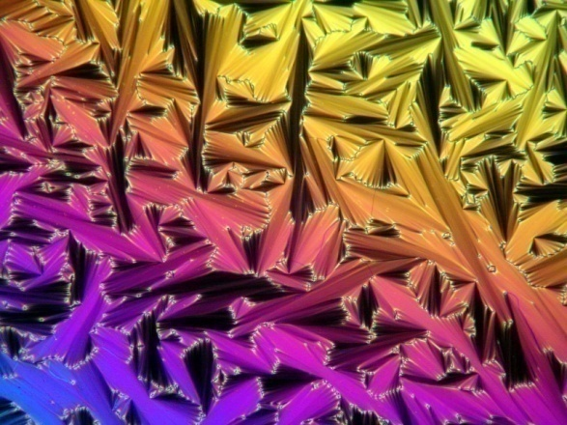
- Focal conic fan-shaped texture of SmA phase (250X).
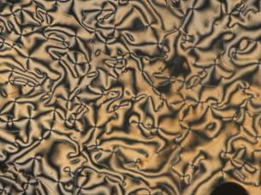

- Schlieren texture of SmC phase (250X).
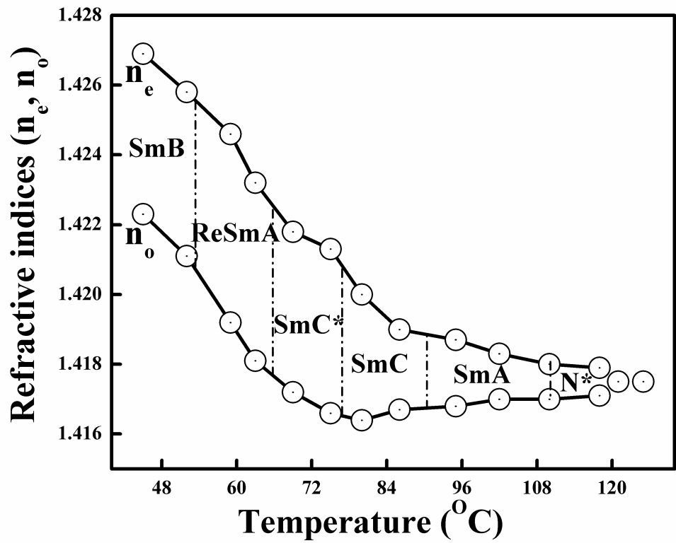
Figure 2. Temperature variations of refractive indices for the mixture of 50% CN in CB7CB.
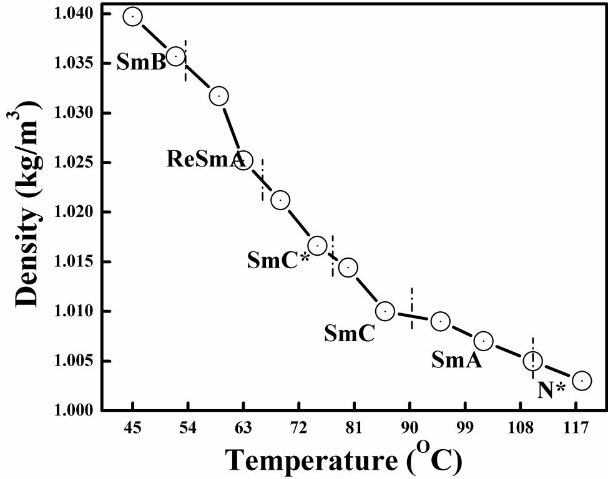

Figure3. Temperature variations of density for the sample of 50% CN in CB7CB.
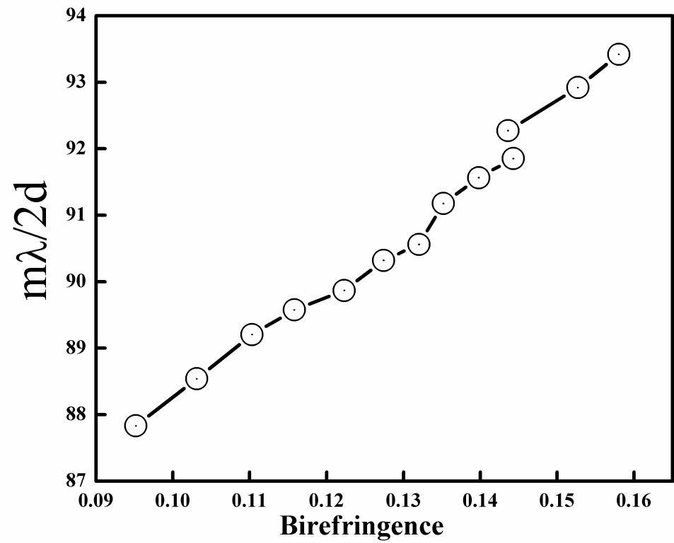
Figure 4. Variation molecular layer spacing’s as function of temperature dependent birefringence
for the sample of 50% CN in CB7CB.

