Rare Earth Element Analysis in Nigeria Bauxite Deposits: Evaluating Concentration, Distribution and Recovery Prospects

Joseph Owolabi^{1,}*, K.O. Emeje², I.C. Okeme³

Abstract
*Author for Correspondence
Joseph Owolabi
E-mail: Josedele85@gmail.com

¹Associate Professor, Department of Physics, Prince Abubakar Audu University, Anyigba, Kogi State, Nigeria
²Lecturer ll, Department of Physics, Prince Abubakar Audu University, Anyigba, Kogi State, Nigeria
³Lecturer ll, Department of Physics, Prince Abubakar Audu University, Anyigba, Kogi State, Nigeria

Received Date: August 25, 2023
Accepted Date: November 18, 2023
Published Date:

Citation: Joseph Owolabi, K.O. Emeje, I.C. Okeme. Rare Earth Element Analysis in Nigeria Bauxite Deposits: Evaluating Concentration, Distribution and Recovery Prospects. Research & Reviews: Journal of Physics. 2023; 12(2): 9–17p.
This study aims to assess the concentration, distribution and recovery prospects of rare earth elements (REEs) in Nigerian bauxite deposits (Plateau and Nassarawa states) using x-ray diffractometer (XRD) and Atomic Absorption Spectroscope (AAS). The significance of rare earth elements in various industries, such as electronics and renewable energy necessitates their thorough analysis in potential sources like bauxite. The realm of rare earth elements is undergoing rapid transformations fueled by technological progress and the escalating demand for these essential components. The spectrum of REEs encompasses the lanthanide series elements, namely La, Ce, Pr, Nd, Pm, Sm, Eu, Gd, Tb, Dy, Ho, Er, Tm, Yb, and Lu, as well as Sc and Y. These metals currently hold utmost significance across a multitude of contemporary technologies, spanning from smartphones, televisions, LED light bulbs, to wind turbines. The methodology involves sample collection, preparation, and analysis using XRD and AAS. The results indicate variations in Rare earth elements concentration across different bauxite deposits in Plateau and Nassarawa states of Nigeri The study spotlight recent breakthroughs in the domain of individual rare earth element separation methods, encompassing both metallurgical and recycling operations. The conclusion highlights the potential economic and technological implications of the findings and underscores the importance of sustainable REE extraction and utilisation. Steering the trajectory of rare earth elements necessitates a multifaceted approach that harmonizes economic advancement with environmental stewardship. By embracing responsible practices, embracing innovation, and nurturing social well-being, nations can unlock the transformative potential of rare earth elements while securing a greener, more prosperous future. The indrustrial applications of REEs resonate across diverse sectors, furnishing substantial economic potential for nations like Nigeria.

Keywords: REE, concentration, distribution, recovery evaluation, deposit

INTRODUCTION
Rare earth elements (REEs) are groups of 17 chemically similar elements that play a pivotal role in modern technology, including electronics, Catalysis and renewable energy. Their high demand has led to extensive research into identifying new sources and efficient extraction methods. Bauxite, a commonly occurring aluminium ore, has the potential to host significant REE concentrations.). In recent decades, the utility of REEs and their alloys has exhibited remarkable expansion, finding applications in computer memory, DVD technology, rechargeable batteries, autocatalytic converters, superconductors, glass additives, fluorescent materials, phosphate binding agents, solar panels, and magnetic resonance imaging (MRI) agents. These metals have become integral to an array of applications, marking an unprecedented era. Table 1 shows REEs and their selected applications. The growing significance REEs in advance electronic technologies and the nuclear industry, coupled with concerns about geopolitical dynamics and supply market vulnerabilities, has economically viable sources of REEs through dedicated research and developmental pursuits. Bauxite, a naturally occurring mineral has been identified to harbour an abundance of sought-after rare earth minerals, thereby rendering it a promising unconventional reservoir of REEs contigent upon geological and mineralogical characteristics. Nigeria, endowed with substantial bauxite deposits prominently situated in Plateau and Nassarawa states, stands to offer an intriguing avenue for exploration [9]. The term rare earth element is usually written in short words to REE and their oxides to REO [8]. The LREE consists of La, Ce, Pr, Nd and Sm, and the HREE have Eu, Gd, Tb, Dy, Ho, Er, Tm, Yb, Lu and Y. This type of groups vary with the LREE extended to include Eu and Gd while the grouping of Sm, Eu, Gd could be termed as SEG or middle or medium REE (MREE) [6, 1]. The occurring of REE in nature in the state with Eu occurring in the state and Ce in the state. Since 1970s, laterite deposits were 8-10 metres thick in southern China have been noticed as being curiched in HREE and constitute an easily recoverable resource [5, 4]. According to them, different terms have been used to describe this style of mineralisation to include ionic days, elution-deposited ore and ion-adsorbed [10]. Abundant in the Earth's crust, REEs, in contrast to many other metals, are seldomly concentrated in minerable ore deposits. These deposits can be categorized as primary, formed through magnetic, hydrothermal, and metamorphic processes, commonly associated with alkaline igneous rocks and carbonation in extensional settings; and secondary, generated through erosion and weathering, encompassing placers, laterites, and bauxite. These deposits can be further classified based on genetic associations, mineralogy, and form of occurrence [7, 11].

These REE gotten from secondary processes are loosely bound via Adsorption processes within clay minerals, but these ores are low grade, between 0.05-0.2% REE, they are near-surface elements and have low extraction and processing costs. The occurrence of some rare earth elements are not properly in metal form. According to [3], Promethium occurs as trace element naturally and has stable isotopes. Also [2] pointed out that the elements, Scandium, yttrium and lanthanides occur together in the same ore deposits and show similar chemical properties. Table 2 shows the rare earth elements present with their atomic numbers, atomic weights and upper crustal abundance in (ppm). Evaluating the concentration, distribution, and recovery prospects of REEs in Nigerian bauxite deposits is critical for understanding the economic and technological viability of exploiting these deposits. Pioneering a sustainable rare earth industry stands to invogorate economic growth, foster job opportunities, prospel technological innovation and diminish import reliance. Emerging green technologies, spanning electric vehicles, batteries, solar panels, and wind turbines, are accelerating the demand for REEs. This surge, coupled with rising prices, anticipates significant growth in the demand for these metals. The exploration for REE resources must transcend terrestrial domains and expand to encompass ocean bottom sediments. Several studies have shown that the form of occurrence, concentration and recovery prospects of rare earth elements from bauxite depends on the mineralogical composition and morphological distribution of bauxite deposit. Because of this, it is pertinent to carry out research on Nigerian bauxite deposit which include Nassarawa and plateau state to understand rare earth element recovery potential. Therefore, the assessment of rare earth elements in Nigeria bauxite deposits via evaluation concentration, distribution and recovery potential is studied.

The results from this study would be valuable for the identification of Nigerian bauxite deposits as a source of REEs and the development of customized methods for the recovery of the REEs which presents a potentially exciting economic prospect for the country which will make the solid mineral sector one of the driving forces of Nigeria economy. This study employs XRD, AAS and SEM-EDS techniques to achieve these objectives. These advanced analytical laboratory techniques will aid the understanding of the mineralogical association and concentration of the rare earth elements in the different Nigeria bauxite deposit alongside toxic and radioactive elements associated with the deposits.
METHODOLOGY
Sample Collection and Preparation
Bauxite Samples were collected from various geographical formations in Plateau state and Nassarawa state. Six Samples were collected altogether, three samples from Plateau state (Bakin ladi) and the other three samples from Nassarawa state (Doma) for AAS analysis, the sample each was first pulverised using mortal and pestle, about 2g of each sample was weighed into the dry digesting tube, 5ml of concentrated Perchloric acid was added into the ratio and stirred. The stock solution was filtered and make up to 50mls with distilled water and the solution was used for atomic absorption spectrophotometer elemental analysis. The principle of atomic absorption spectrophotometer is based upon the concept that atoms of an element can absorb electromagnetic radiation. This occurs when the element is atomized and the wavelength of light absorbed is specific to each element to be determined. AAS analysis was conducted to quantitatively determine the concentration of REEs in the bauxite samples. The powdered samples were subjected to acid digestion to extract the REEs which were then analyzed using the AAS instrument.

For XRD analysis was performed to identify the mineralogical composition of the bauxite samples and ascertain the presence of REE-bearing minerals. The XRD data were used to estimate the relative abundances of different mineral phases. The samples were cleaned, dried, and finely powdered to ensure homogeneity and good representation, then subjected to X - ray diffraction analysis for mineral identification. The diffraction data obtained was compared to that of the standard data of minerals from the mineral powder diffraction file, ICDD which contained and includes the standard data of more than 3000 minerals. Similar diffraction data means the same minerals to standard minerals which exist in the soil sample. SEM- EDS analysis shows surface morphology and particle size of the samples. EDS reveals well defined peaks identified as characteristics peaks. The bauxite samples were put to an appropriate size to fit in the specimen chamber and mounted rigidly on a specimen holder called a specimen stub. Samples were coated with platinum coating of electrically conducting material deposited on the samples by low-vacuum sputter coating. SEM chamber where the working distance is short and the electron optical column is differentially pumped to keep vacuum adequately low at the electron gum. The high pressure region around the sample in the ESEM neutralizes charge and provides an amplification of the secondary electron signal.

Table 1. REEs and their selected applications.
Elements | Selected Applications
Scandium (Sc) | Super alloys, x-ray tubes, lights,semiconductors
Yttrium (Y) | Ceramics, metal alloys, rechargeable batteries
Lanthanum (La) | Optical glass, camera lenses
Cerium (Ce) | Water purifiers, catalysts, radiation shielding
Praseodymium (Pr) | Magnets, lasers, pigment
Neodymium (Nd) | Hard disc drives, infrared filters
Samarium (Sm)  Europium (Eu)  Gadolinium (Gd)  Terbium (Tb)  Dysprosium (Dy)  Holmium (Ho)  Erbium (Er)  Thulium (Tm)  Ytterbium (Yb)  Lutetium (Lu) | Microwave filters, high temperature magnets  Liquid crystal displays, fluorescent lighting  Memory chips, nuclear reactor shielding,  Green phosphors, optical computer memories  Permanent magnets, lasers, catalysts  Lasers, catalysts, magnets  Infrared lasers, vanadium alloys, optical fiber  Portable x-ray machines, microwave oven  Infrared lasers, chemical reducing agent  High reflective index glass, x-ray phosphors
United States Geological Survey. Potential uses of REEs found in marine minerals (2020).
Table 2. Rare earth elements.
Element | Atomic number | Symbol | Atomic weight | Upper crustal abundance (ppm)
Yttrium | 39 | Y | 88.91 | 22
Lanthanum | 57 | La | 138.91 | 30
Cerium | 58 | Ce | 140.12 | 64
Praseodymium | 59 | Pr | 140.12 | 7.2
Neodymium | 60 | Nd | 143.32 | 2.5
Samarium | 62 | Sm | 150.35 | 4.6
Europium | 63 | Eu | 152.01 | 0.87
Gadolinium | 64 | Gd | 157.26 | 3.75
Terbium | 65 | Tb | 158.89 | 0.66
Dysprosium | 66 | Dy | 162.35 | 3.72
Holmium | 67 | Ho | 164.87 | 0.82
Erbium | 68 | Tm | 168.92 | 2.20
Thulium | 69 | Thm | 169.62 | 0.34
Ytterbium | 70 | Yb | 172.12 | 2.31
Lutetium | 71 | Lu | 174.89 | 0.33
Castor and Hedrick, 2006: Phillip & Robert 2018; Pauruand et al, 2012

RESULTS AND DISCUSSION
The Quantitative analysis using atomic Absorption Spectroscope (AAS) indicated varying concentrations of REEs in the bauxite samples. Some deposits in Plateau state (Bakin ladi) exhibited promising concentrations of specific REEs while others had lower concentrations (Figures 1 and 2). The same thing applicable to other region in Nassarawa states deposits as shown in Table 1.

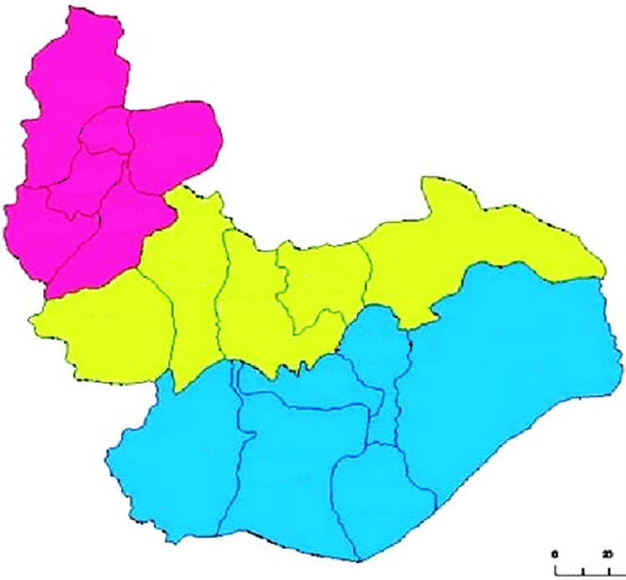
Bassa
Jos
north
Jos
south
Riyom
Barkin
ladi
Mangu
Bokkos
Pankshin
Kanke
Kanam
Qua'an pan
Mikang
langtang north
Shendam
Wase
langtang south
0
20
Figure 1. Geological map of plateau state.
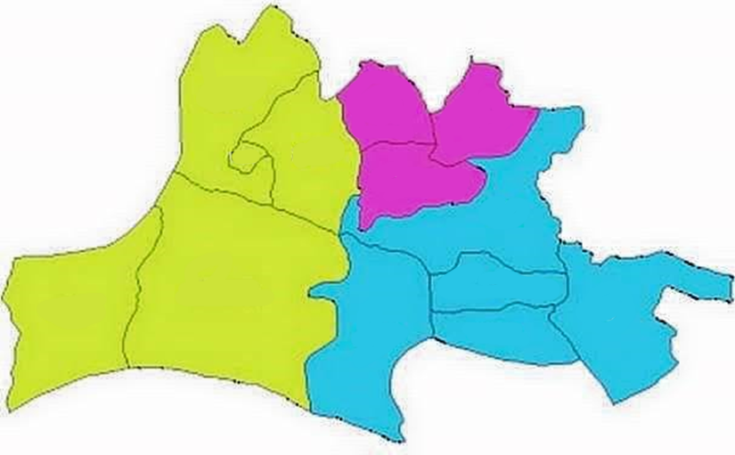
Karu
Kokona
Nasarawa
Toto
Keffi
Akwanga
Wamba
Nasarawa Egon
Doma
Obi
Lafia
Awe
Keana
Figure 2. Soil profile in sample locations in Nassarawa state.

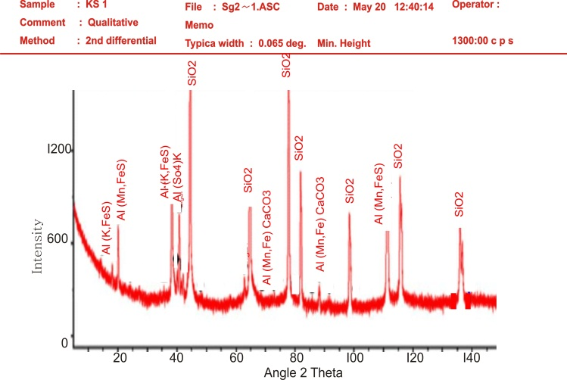
Figure 3. XRD diffraction pattern for sample1.

*KS1 and KS2 mean collected bauxite samples 1 & 2.

The XRD results revealed the presence of various mineral phases in the bauxite samples. All the samples exhibited higher abundance of REE-bearing minerals, indicating the potential for REE enrichment. The distribution of rare earth elements in the two sampled states different deposits displayed variations, suggesting the influence of geological and mineralogical factors on rare earth elements enrichment. The XRD analysis is based on passing x-ray beam through the sample. The x-ray identifies the structural layers which is dependent on the d-spacing of the soil minerals. The d-spacing is the exact spacing of the staking of the crystal lattices which indicates the arrangement of the atoms in a mineral. The x-ray on passing through the samples give peaks that is typical of each type of diffracted (Figure 3) along a group of planes as shown in Figures 4–8. The way they are diffracted is the characteristics of the arrangement of the atoms within the mineral samples. According to Bragg’s law of diffraction, electromagnetic waves reveal the atomic structure of crystals nƛ = 2dsinθ. The powdered sample show that the diffracted beams form continuous cones and each cone intersects the film giving diffraction lines.

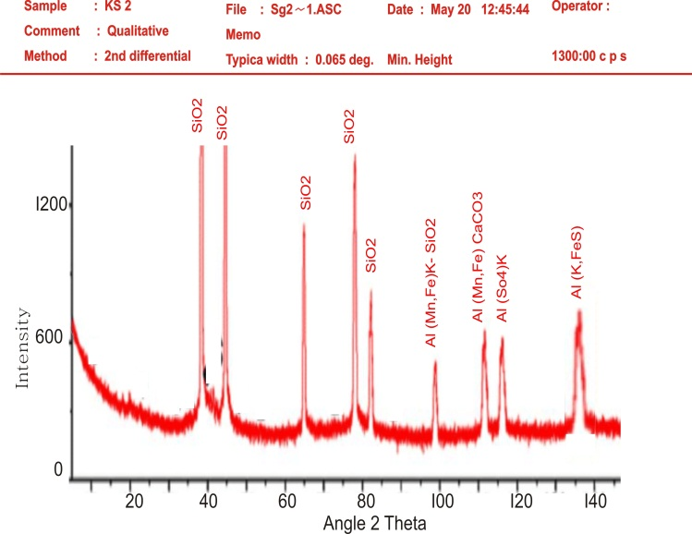
Figure 4. XRD diffraction pattern for sample2

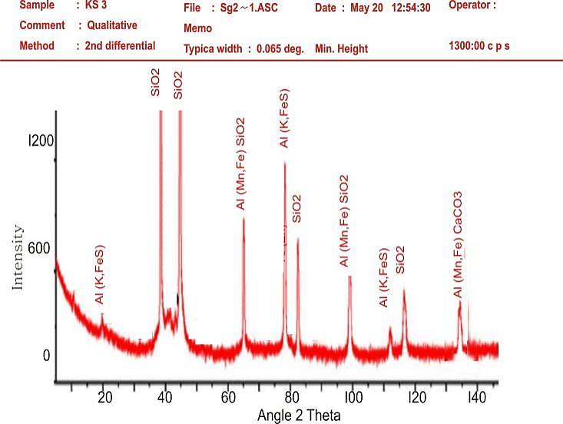
Figure 5. XRD diffraction pattern for sample3.

The Miller indices in the Figures 4–8 indicate the reciprocals of the fractional intercepts which the plane makes with crystallographic axis. The SEM in Figures 9 and 10 produce very high resolution images of magnification 9000x at 5um and 20um. Due to the very narrow electron beam, SEM micrographs have a large depth of field yielding a characteristic three- dimensional appearance useful for understanding the surface structure of the bauxite samples. EDS provides information about the distribution of different elements in bauxite samples. It identifies the composition and measure the abundance of elements in the sample. The energy dispersive x-ray spectroscopy (EDS) analysis of the collected bauxite samples in Figure 11 shows the elemental composition of the collected sample- Si, Mg, C,O, Ca, Fe, S, Na, K, and Al with their weight percentages. The distribution of REEs across different deposits displayed variations, suggesting the influence of geological and mineralogical factors on REE enrichment.

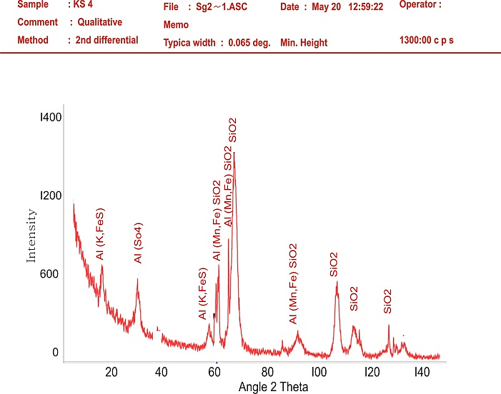
Figure 6. XRD diffraction pattern for sample4.

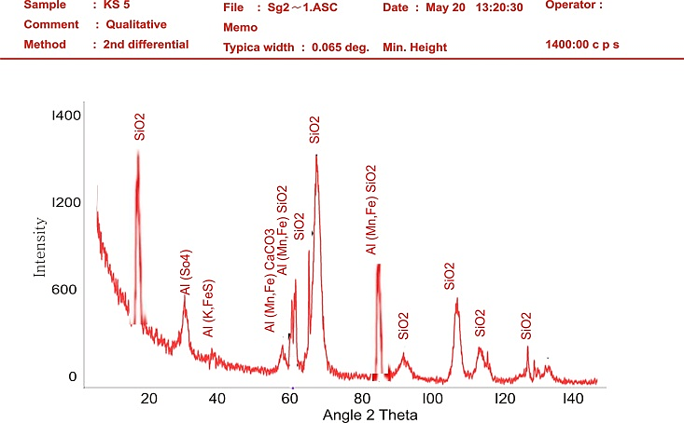
Figure 7. XRD diffraction pattern for sample5.
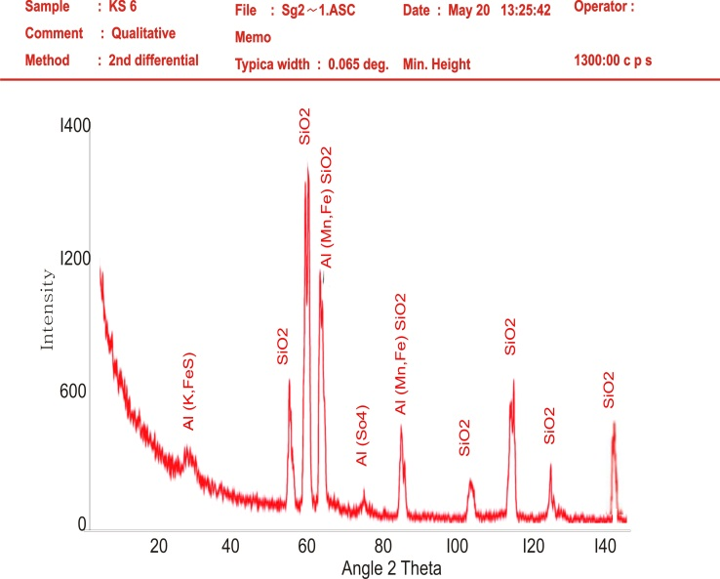
Figure 8. XRD diffraction pattern for sample6.

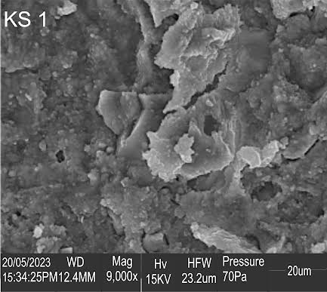 | 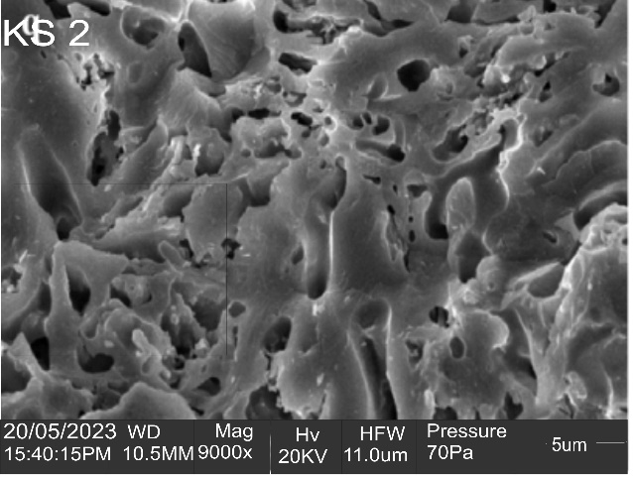
Figure 9. Scanning Electron Microscope  (SEM) image bauxite sample at  magnification 9000x (20um). | Figure 10. Scanning Electron Microscope (SEM) image of bauxite sample at magnification 9000x (5um).

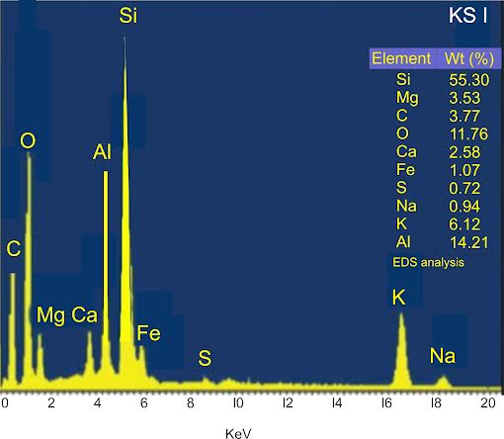
Figure 11. Energy dispersive spectroscope (EDS) spectrum of bauxite sample.
CONCLUSION
The study underscores the significance of evaluating rare earth elements in Bauxite deposits due to their strategic importance in modern technologies. The XRD, SEM-EDS and AAS analyses provided insights into the mineralogical composition, concentration, and distribution of REEs in Nigerian bauxite deposits. The variations in REE concentrations highlight the need for comprehensive assessment before considering large-scale extraction. The findings have implications for economic viability and sustainable resource management. This study contributes to the broader understanding of REE potential in unconventional sources and emphasizes the importance of responsible extraction and utilization practices. Further research is recommended to explore efficient extraction methods and techno economic feasibility.

Acknowledgement
We hereby appreciate TET FUND for sponsoring this research work (through research project intervention. We also hereby appreciate Prince Abubakar Audu University, Anyigba for providing the enabling environment to access and utilizes the grant.

REFERENCES
- Balaram. V (2019). A review of applications, occurrence exploration, analysis, Recycling, and environmental impact. Geoscience frontiers, 10, 1285-1303.
- Bolaram. V (2017). Field- portable analytical instruments in mineral exploration, past, present and future. Journal of Applied Geochemistry, 19(4), 382-399.
- Castor and Hendrik (2006). Rare earth elements. Industrial minerals and rocks: commodities, markets and uses. Society for mining mineralogy. United States, pp769-792.
- Chi and Tian (2008). Weathered crust elution deposited rare earth ores. Nova science publication, Inc. New York. Pp1-288.
- Kynicky, smith and Xu. C (2012). Diversity of rare earth deposits: the key example of China. Elements, 8, 361-367.
- Georgios, Konstantuios, Vatalis (2015). Rare earth elements: industrial applications and economic dependency of Europe. International conference applied economics. Procedia economics and finance 24, 126-135.
- Owolabi J.A (2023). Assessment of trace and rare earth element distribution and speciation in Bauxite deposits across Ekiti and Ondo states, Nigeria. Engerineering journal of technology, 8, 20-35.
- Phillip L. And Robert k.(2018). Evaluating rare earth element deposits. Https//www.researchgate.net/publication/323452073.
- Tyler G. (2004). Rare earth elements in soil and plant systems-a review plant and soil, 267, 191-206.
- United States Geological Survey. Potential uses of rare earth elements found in marine minerals. https://www.usgs.gov/media/images/potential-uses-rare-earth-elements-found-marine-minerals (accessed 20 July 2020)
- Zhu Y. (2004). Gadolinium anomaly in the distribution of rare earth elements observed for coastal seawater and river waters around Nagoya city. Bulletin of the chemical society of Japan, 77, 1835-1842.

